Velocity : it is a measure of a team performance. E.g. Story points per iteration.
Cycle Time: It is a time it takes for a feature to make it from start (when it enters backlog) all the way to finish (when it is "done"). Shorter cycle time is better; Minimal Marketable Feature (Chapter 6).
Burn Rate: It shows the amount of cost estimated over a given period of time.
Product Backlog: It is a list that keeps functionality planned for the project, sorted by value to the customer from highest to lowest. As functionality is completed, it is moved off the list.
- it is the responsibility of the "Product Owner" or the customer.
- Backlog Grooming: prioritizing items as new user stories are added. Should be done at least every iteration.
- Backlog should be D.E.E.P.
  - Detailed Appropriately: Should have enough details; neither too much nor too little.
  - Estimable: User stories near the top should have enough detail to be estimated.
  - Emergent: Backlog grows and changes over time and it is not static.
  - Prioritized: The most valuable stories should be on top.
Iteration Backlog: Contains list of stories to be completed in a current iteration. It is maintained by the team, unlike Product Backlog, which is the responsibility of the product owner.
Product Quality: Quality should be maintained. Corrected, if signs of quality issues start to appear.
Escaped Defects: Defects that escaped testing by developers and quality control measures and made it into the customer's hand. If customer finds it, it's classified as an escaped defect. This metric should be tracked for trending. And should be looked at the root cause if it starts to have an upward trend.
Frequent Verification & Validation:
- Verification: it is concerned with ensuring that the functionality meets specification.
- Validation: it ensures that the functionality does what it was intended to do.
- Both are done frequently to keep the project on track and to quickly detect any deviation from value.
Agile Smells: These are documented "smells" that describe issues affecting the team or the product. Agile Smells are a way to describe and quickly recognize and diagnose common problems so that a remedy may be pursued.
Embracing Change: Agile welcomes change. Traditional projects view change with caution.
Refactoring: Refactoring should be often performed because of a "smell" or because the team recognizes the need. Refactoring should not change the code behavior and should be followed by complete regression test to ensure the functionality.
Information Radiators: A dashboard in a highly visible area that indicates the progress of the project to team and potentially to the stakeholders.
Osmotic Communication: It helps the team members pick up on information from a communication among other team members. Colocation greatly helps in this regard.
Burn-Down Charts: It shows number of story point completed in iteration.
Burn-UP Charts: It shows the story points accepted in iteration.
Kanban Board (Task Board): It is a component of an information radiator. It is placed in a highly visible area. It contains information about project's progress with respect to workflows (e.g. plan, do , check, done).
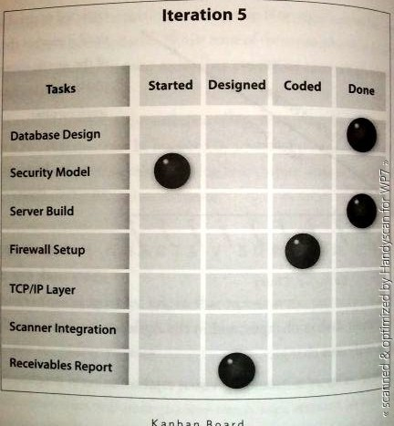

Earned Value Management (EVM): It tracks the actual percentage of work complete at this point in time for the total schedule. Since in Agile projects do not know the total schedule , EVM can be calculated at the iteration level by using velocity and burn rate.
Cumulative Flow Diagrams:
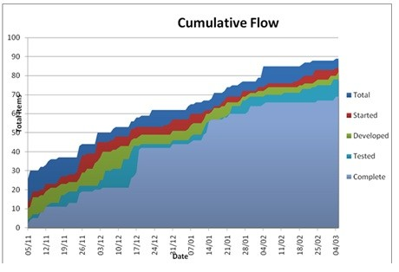

Incremental Delivery:
- Giving customer working software early and delivering more value quickly.
- Allows customer to work with the system before it is complete, allowing time for changes with less impact.
- Doesn’t plan everything up front. Instead the team can do some planning, deliver some value, gain valuable feedback, and repeat the cycle.
- It prioritize the most valuable pieces of functionality so that it gets to customer quickly.

Kaizen: It is a plan for improvement by making very small changes, measuring impact, and repeating. It encourages changes from the worker rather than asking management what should be changed.
Spikes: It is an experimental work; throw away work. It is used to evaluate some solution for the project.
Risk-Adjusted-Backlog: Risk is tied to value, and the two must be evaluated in light of each other.

